SIU SUPPLIERS INQUIRY

With the responsibility of SIU Purchasing Inquiry, AIS users will be able to inquire vendors and see various information on the vendors including minority status, business type, conflict of interest, etc. In the future, they will be able to inquire insurance status.

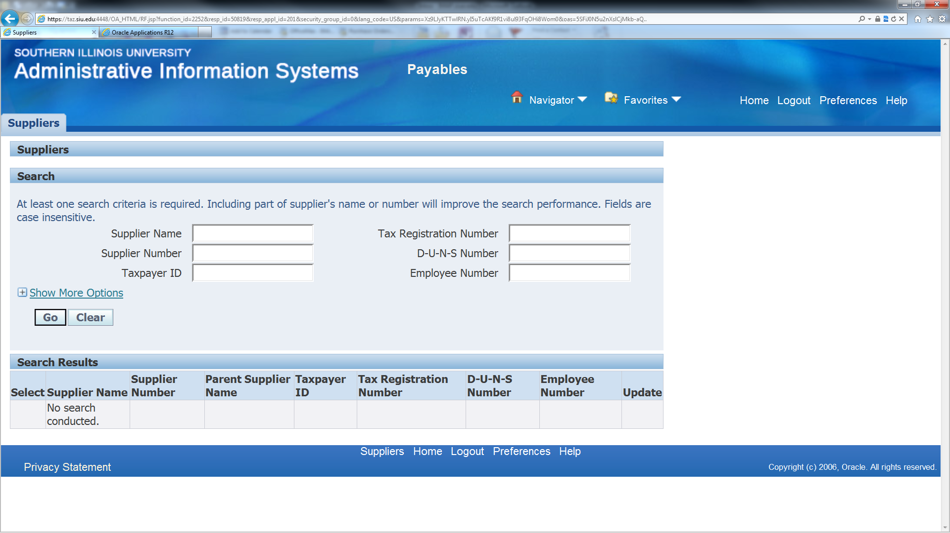

The field to find W-9, BEP, Conflict of Interest, and PS supplier (Physicians and Surgeons – School of Medicine suppliers) information is under Organization. Under Business Classification, users will find the business type, Minority and if the supplier is woman-owned and/or small business. If there is a 5 character code (all Alpha), that indicates that the vendor is a certified minority supplier with State of Illinois Central Management Services Business Enterprise Program.

